User Manual

- Introduction

  - Project Overview

We plan to develop an online portal that would provide basic medical assistance to the general public.

This project aims to-
- Provide Basic First-aid information
- Evaluate one’s symptoms for a disease
- Suggest treatment and cure for major diseases
- Provide various health tips
- Facilitate maintenance of medical history
- Add relation and family members to their accounts
Supply information and Links about major hospital and NGOs

1.2 Project motivation

With the outset of the IT boom, everyone prefers to access all kinds of data through the internet itself. Health is a major issue today which often gets neglected in the busy schedule of today.
Often, they ignore everyday symptoms which may later evolve into something more serious. Also, visits to doctors or hospitals may not be possible due to various other factors such as physical constraints, unavailability of medical services etc. Hence, there is a need for dispatch of authentic medical information through an online portal to help the crowd at large.
Another point to note is that maintaining and accessing past records of medical history is often complicated with medical help etc. spread over various doctors and hospitals. Maintaining all the records at one place for future reference is another feature required in today’s time and will be provided by this website

- Documentation

2.1 Document Overview

This document, aims at helping the user in understanding how to use our website, its workflow and how to use it efficiently and effectively. The document explains the functionalities of all tabs, buttons and menu options available to users of various profiles.

- Support

3.1 Systems Requirements

- The end user should be able to access the system with any machine that has internet connection with an optimum speed.
- There is no hardware requirement other than PC on the user side, as all the data is stored on the central database.

Developer Side:
- 800 MHz Intel Pentium IV or equivalent
- 2 GB of memory
- Display Adapter VGA(800x600 resolution and 256 color mode)
- Supported Operating System: Windows XP/Vista/Windows 7
- Xampp/Wamp server
- Adobe Dreamweaver for client script writing editor.

User Side:
- 800 MHz Intel Pentium IV or equivalent
- Display Adapter VGA(800x600 resolution and 256 color mode)
- Supported Operating System: Windows XP/Vista/Windows 7

- Using the Software

- Login
Already registered user can use the services provided by Mediline website by entering valid username and password here. If any of the fields are vacant or invalid,same page will be loaded.

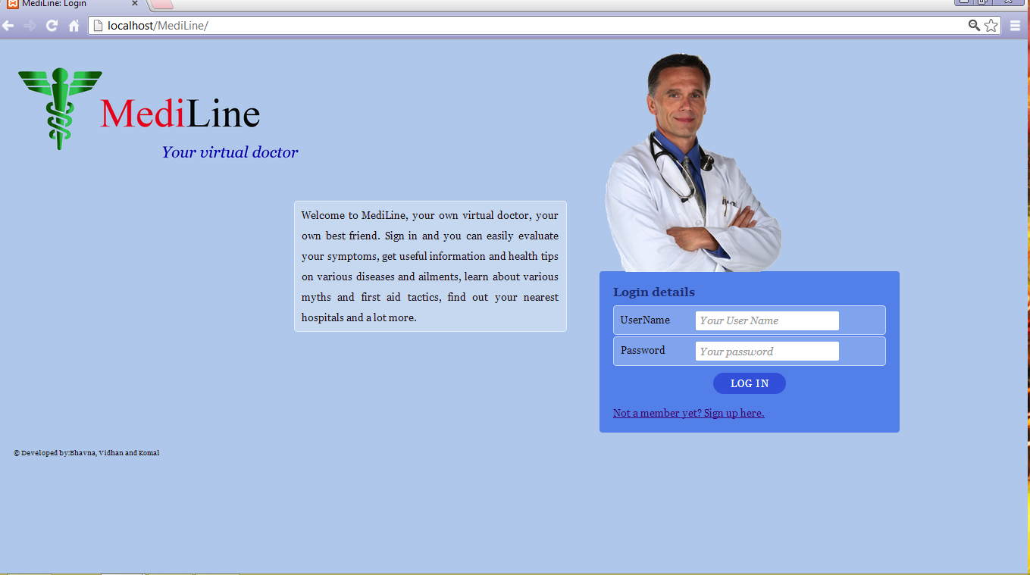
2. Register/Sign Up
  - To sign up, Please Click on “Not a member yet?Sign up here”
  - New users can register to Mediline website by providing the required details here
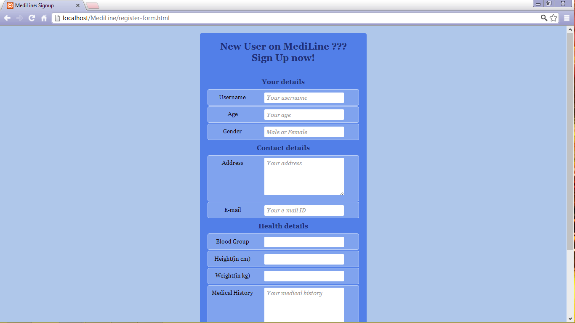

Table of contents:

1. Introduction………………………………………………………………….3
2. Installation Plan…………………………………………………………….3
2.1 XAMPP Installation…………………………………………..3

1. Introduction
This document is a stepwise installation guide for installing e-PAATHSHALA based website for study material on server as well on client side.
2. Installation Plan
XAMPP is required to run the server side of the software. Installing process is as following-
2.1 XAMPP Installation:
- Get XAMPP
Go to apachefriends.org and download XAMPP for Windows. There are several XAMPP packages to download. Installer is about 1/2 the size of the same package as a zip file.
- Create XAMPP web server
- Installing XAMPP
Run the installer, eventually you will be presented with an option about where to install the package. We told it to install it in a new folder called C:\X_server which XAMPP will create. You could use the browse button to point to a location.
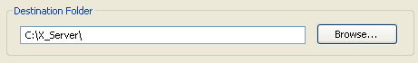
Continue with the installation, this will take a while!
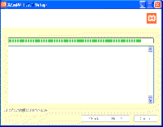
- Installation info screen
Eventually you will be presented with the option to install Apache, MySQL, Filezilla and Mercury as a service.
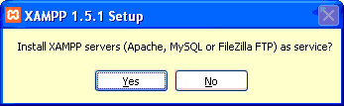
- It’s probably best to choose “No” for now. You can always enable these as services later.
- Next you’ll be asked if you want to start the XAMPP Control Panel.
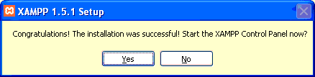
- Click the “No” button.
- Launch XAMPP
There are several ways to start your web server.
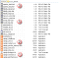

- Server directory start/stop files
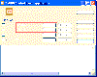

One way to start/stop: XAMPP control panel
1. On your Desktop, locate the shortcut XAMPP icon and double click to launch the Control Panel.
- When the XAMPP Control Panel has launched, click the “Start” buttons for Apache and MySQL (see below).
2. In the folder you installed XAMPP, look for the XAMPP_start, or XAMPP_restart icon.
- When XAMPP start has finished, both Apache and MySQL have been started.
3. In the folder you installed XAMPP, look for the Apache start and MySQL start icons
- When Apache and MySQL start icons are used, two black windows command window should remain open
- If all is well you will see something like this.
If Apache fails to run i.e. the "Running" text with the green background keeps disappearing) and you are using Skype or another program that uses port 80 e.g. IIS - please review "Troubleshooting" at the end of these instructions.
Then you have to install the PHP curl library :
1. Open the php.ini file found in the php/php.ini folder
(older versions of XAMPP use moodle/apache/bin folder)
2. Find the line: ;extension=php_curl.dll
3. Remove the ; at the beginning of the line
4. Restart Apache if necessary

Create the MySQL database
To create a MySQL database for your Moodle “site” we will use the phpMyAdmin utility included with XAMPP.
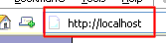
- To access this launch the web browser of your choice (Firefox is used in this example), type http://localhost/xampp/ in the address bar.

- The XAMPP default page will be displayed, click the link for your preferred language – we will be using English.
- From the menu on the left, click on “phpMyAdmin”
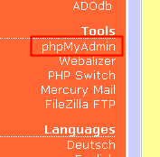
- When phpMy Admin has launched in your browser window, enter the name of your database in the “Create new database” field.
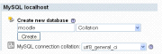

Center of initial phpMyAdmin screen
- From the "Collation" drop down list select "utf8_unicode_ci"
- Click the “Create” button to create the database.
You should see the database on the left with your moodle MySQL database name without files in it and/or a notice that it was created.
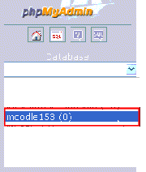

Example of a phpMyAdmin database list, click on moodle to add MySQL users
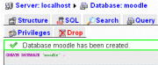

The database is corrected, notice the privileges icon

